QUARTERLY EXAMINATION 2023 – 2024
MATHEMATICS
MARKS: 50 CLASS: IX TIME: 2 HRS
General Instructions:
- This question paper has 5 sections A – E
- Section A has 10 MCQs carrying 1 mark each.
- Section B has 5 questions carrying 02 marks each.
- Section C has 4 questions carrying 03 marks each.
- Section D has 2 questions carrying 05 marks each.
- Section E has 2 case based integrated units of assessment (04 marks each) with subparts of the values of 1, 1 and 2 marks each respectively.
- All questions are compulsory.
SECTION – A
Section A consists of 10 questions of 1 mark each.
- The product of any two irrational numbers is
- Always an irrational number b) always a rational number c) always an integer
d) sometimes rational, sometimes irrational
- Value of $\sqrt[4]{{(81)}^{-2}}$ is
- $\frac{1}{9}$ b) $\frac{1}{3}$ c) 9 d) $\frac{1}{81}$
- Degree of the polynomial $4x^{4}+0x^{3}+0x^{5}+5x+7$ is
- 4 b) 5 c) 3 d) 7
- If $p\left(x\right)= x^{2}-2\sqrt{2} x+1$, then $p\left(2\sqrt{2}\right)$ is equal to
- 0 b) 1 c) $4\sqrt{2}$ d) $8\sqrt{2}+1$
- If y coordinate of a point is zero, then this point always lies
- In I quadrant b) in II quadrant c) on x – axis d) on y – axis
- The ordinate of the point (4, - 5) is
- 4 b) 5 c) – 5 d) none of these
- The number of lines that can pass through a given point is
- Two b) none c) only one d) infinitely many

- If the point P lies in between M and N, and C is the midpoint of MP, then
- MC + PN = MN b) MP + CP = MN c) MC + CN = MN d) CP + CN = MN
DIRECTION: In the question number 9 and 10, a statement of assertion (A) is followed by a statement of Reason (R).
Choose the correct option:
- Statement A (Assertion): The difference of rational and irrational number is irrational.
Statement B (Reason) : Product of rational and irrational is irrational
- Both assertion (A) and reason (R) are true and reason (R) is the correct explanation of assertion (A).
- Both assertion(A) and reason(R) are true and reason(R) is not correct explanation of assertion (A)
- Assertion (A) is true but reason (R) is false.
- Assertion (A) is false but reason (R) is true.
- Statement A (Assertion): If AB = CD, then AC = BD.
Statement B (Reason): Above statement we can prove by Euclid’s axiom if equals are added to equals, then the wholes are equal.
- Both assertion (A) and reason (R) are true and reason (R) is the correct explanation of assertion (A).
- Both assertion(A) and reason(R) are true and reason(R) is not correct explanation of assertion (A)
- Assertion (A) is true but reason (R) is false.
- Assertion (A) is false but reason (R) is true.
SECTION – B
Section B consists of 5 questions of 2 marks each.
- Find four rational numbers between $\frac{5}{7}$ and $\frac{6}{7}$
- Find the value of k, if $y+3$ is a factor of $3y^{2}+ky+6$.
- Evaluate 105 x 108 without multiplying directly.
- If the point $\left(3, 4\right)$ lies on the graph of $3x=ay+7$, then find the value of $a$.
- Write any two Euclid’s postulates.
SECTION C
Section C consists of 4 questions of 3 marks each.
- Represent $\sqrt{8.1}$ on the number line.
- Express $0.1 \overline{3 4}$ in the form of $\frac{p}{q}$, where p and q are integers and $q≠0$
- Factorise $x^{3}-3x^{2}-9x-5$.
- In the figure, if $AC=BD$, then prove that $AB=CD$
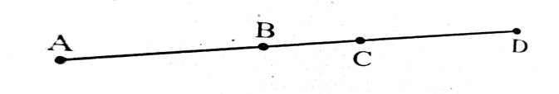
SECTION D
Section D consists of 2 questions of 5 marks each.
- If $x=\frac{\sqrt{3}+\sqrt{2}}{\sqrt{3}-\sqrt{2}}$ and $y=\frac{\sqrt{3}-\sqrt{2}}{\sqrt{3}+\sqrt{2}}$, then find the values of $x^{2}+y^{2}$
- Factorise the following using suitable identity:
- $2x^{2}+y^{2}+8z^{2}-2\sqrt{2}xy+4\sqrt{2}yz-8zx$
- $64m^{3}-343n^{3}$

SECTION E
Case study based questions are compulsory.
- CASE STUDY – 1
Students of a school are standing in rows and columns in their playground for a drill practice. A, B, C and D are the positions of four students as shown in the figure.
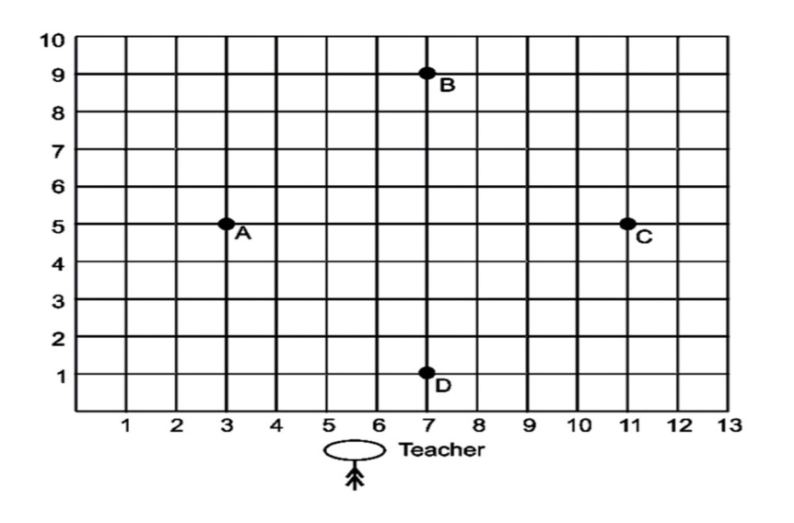
- What are the coordinates of A and B respectively? (1M)
- What are the coordinates of C and D respectively? (1M)
- What is the distance between BD and AC and name the shape of quadrilateral formed by joining these points? (2M)

- CASE STUDY – 2
To recapitulate the concept of polynomials a teacher bought a box with some slips of polynomial written on them in the class. She asked the students to pick a slip turn wise and say any four lines about the polynomial written on it.


- Saanvi got the polynomial $p\left(x\right)=1-x^{2}$. What type of polynomial is it? (1M)
- Varun got the polynomial $p\left(y\right)= y^{2}-5y+6$; calculate the value of $p(-1)$. (1M)
- One of the slip had polynomial $x^{2}-6x+9$ written on it. Write its factors. (2M)

